**Jackson Pollock and the Art of the Cold Call**

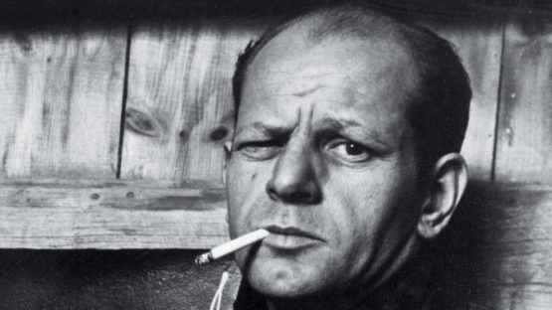

I’ve long held the belief that cold calling is like the work of Jackson Pollock. Done well it is mesmerizing in its simplicity, but the true artform is seen so rarely that messy approximations are often mistaken for the real thing, and hence detractors abound. It is not just in its final form, but in the work towards perfecting the art that analogies can be drawn. If you’ll indulge me for a couple of minutes, here are my top tips for mastering the art of the cold call through expressionism!

**An explosion of random energy and meaninglessness**

It sounds obvious, but being prepared, not just to make the call but to have the call received is essential. Think about your audience on the end of the line. What will make them engage in conversation with you rather than use your one-way monologue to quickly check their diary or the football score? What are their pain points? What issues are they grappling with that you might be able to address? Identifying a legislative or compliance issue, for example, that is impacting their industry can encourage dialogue, and grouping your calls by customer type will help you develop a flow. Structure your calls so you learn something about the company and your prospect and share with them some critical info you want to impart that is relevant to the information they divulge. No matter your levels of enthusiasm, calls where the sales person is unprepared to engage in a two-way dialogue are just, to quote a Pollock detractor, ‘an explosion of random energy and meaninglessness’ and this is where much of cold calling gets its bad press.

**A mix of controllable and uncontrollable forces**

Pollock considered the canvas and his arm movements as controllable forces and the movement of the paint as an uncontrollable force. A large part of the art of the cold call is having the ability to move the conversation in the right direction whilst still being able to absorb the unknowns the prospect might throw at you. In your control is the desired end goal – make it achievable. If your desired outcome of a cold call is a sale your conversion rate will always be low. Instead be realistic about what you can achieve. Make the goal to start a conversation with a good quality prospect. For example, ‘Is your team responsible for GDPR compliance?’ ‘It’s a mammoth job. Are you running it in-house or using external support?’ These open but guiding questions help you control the conversation, encourage information flow from the prospect and at the same time enable you to qualify them as a good lead. Where forces outside of your control, an unresponsive prospect, or a bad lead generation list, come into play these questions also help you control the amount of time you spend on dead-end leads. In this way you master the art of mixing controllable and uncontrollable forces to get you to the desired end-result faster.

**It is only when I lose contact with the painting that the result is a mess**

In sales terms this can simply be translated as ‘listen and respond’. Persisting with a call at all costs is a fast route to failure. No matter how fired-up you are to move a cold call to a warm lead, responding to verbal ques and your own gut instinct is imperative. A second sense that tells you somebody is pushed for time or distracted should largely be acted upon. That doesn’t mean hanging-up at speed but it does mean taking the time to be humble, to understand that your call isn’t the most pressing thing on their agenda and suggesting you follow up at a different time or in a different way. Losing contact with basic common decencies results in a disengaged prospect and messy result. Leaving the door open via a positive experience that respects the prospects time gives you license to go-back for a second try. In fact, in many instances it will often give you a warmer welcome than the initial cold call.

**Stand back and observe the results**

Despite the naturally free style of Pollock’s work he would often go back to seemingly finished piece to add finishing touches. Analyzing the results of your efforts is essential. Tracking your conversation rate to ensure you are improving and taking time to reflect on how well a call went, and where you might have improved is an essential part of mastering the art. Like Pollock, don’t be afraid to take inspiration from others. Ask to sit in on cold calls with colleagues you know are getting good results. Ask for their feedback on your efforts and don’t be afraid to ask for time to practise in mock situations. After all, it is only through practice than anybody in any discipline can become a master of their art.

Tony Wand is a Senior Consultant at Strategy to Revenue, the award-winning sales enablement company

(words: 825)